MAP FOR STATEMENT FOR BASIS OF INVESTIGATION
CONDEMNATION PRELIMINARY REDEVELOPMENT INVESTIGATION
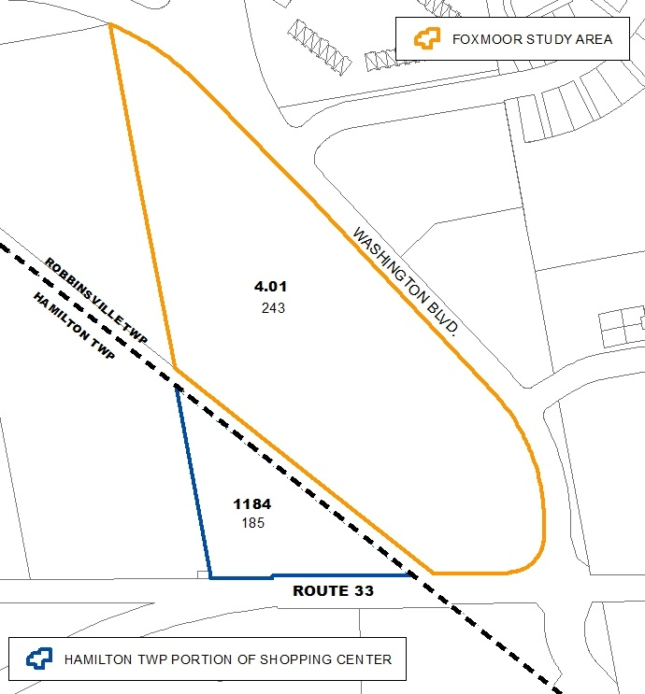
FOXMOOR STUDY AREA

